FLASHY LEARNER

-Devansh Jain (19BCI0173)

First Of All I wasn’t Able to Complete the app because of lack of Time and Online Classes And I didn’t had Enough knowledge Of The App Dev but Im posting Whatever I ve Made. Plz read the word document fully.

DESIGN

SCREEN - 1

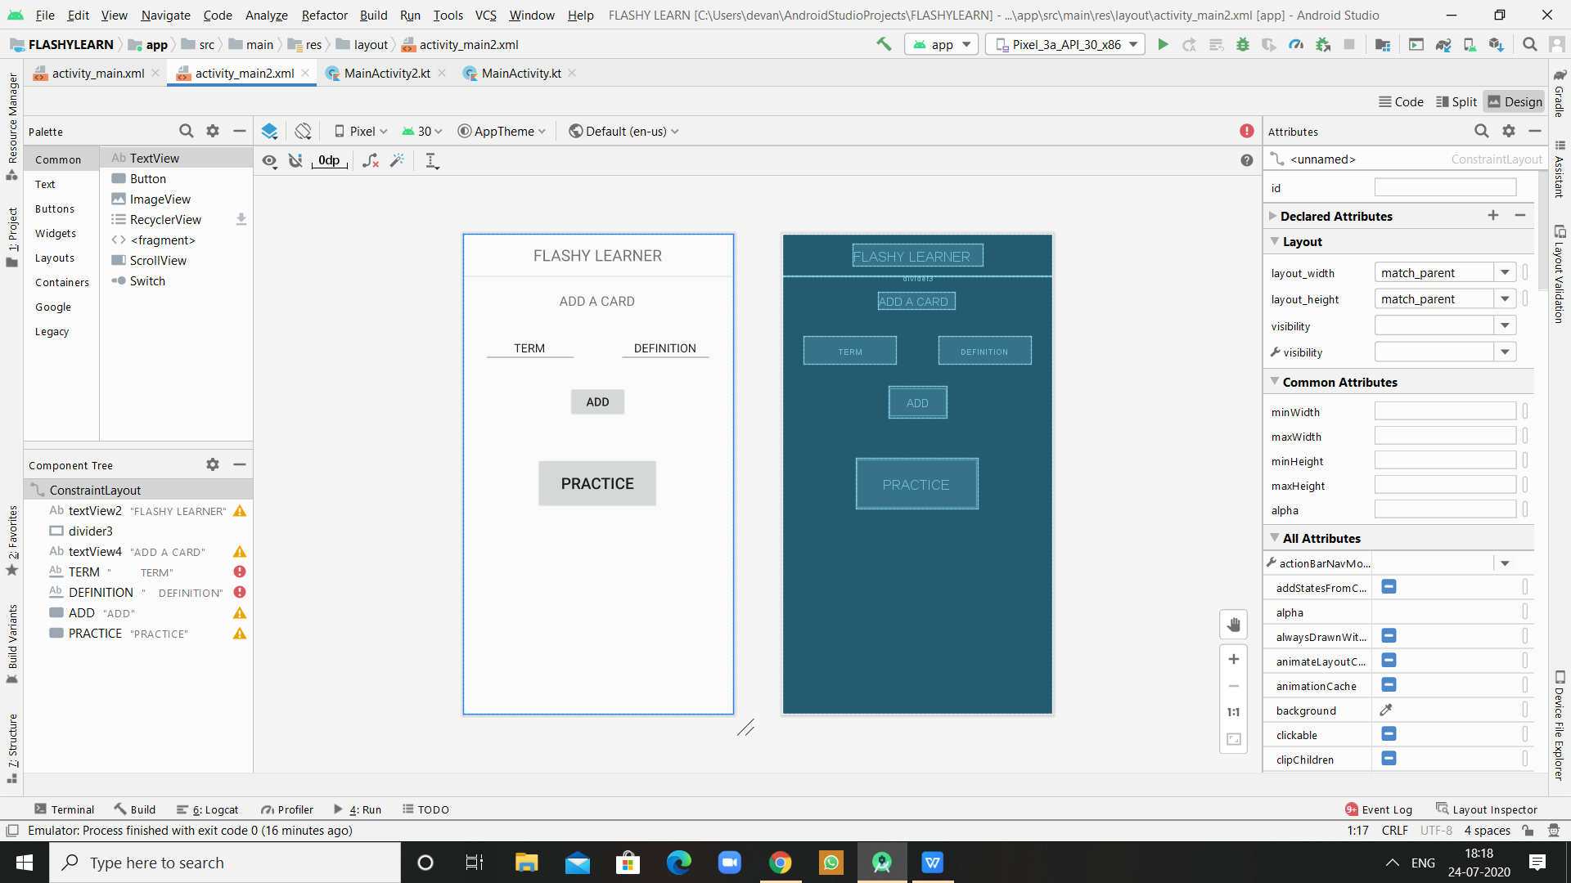

1. So This is my Starting Screen in which user will be able to add a term and Definition and together it will be called a ‘Card’ OR ‘Flash Card’
2. The user will be able to add cards of his choice and when he has finished the adding he can press the practise button
3. The Practice Button will take to the screen 2 in which the user can practise their Flash Cards.

SCREEN - 2

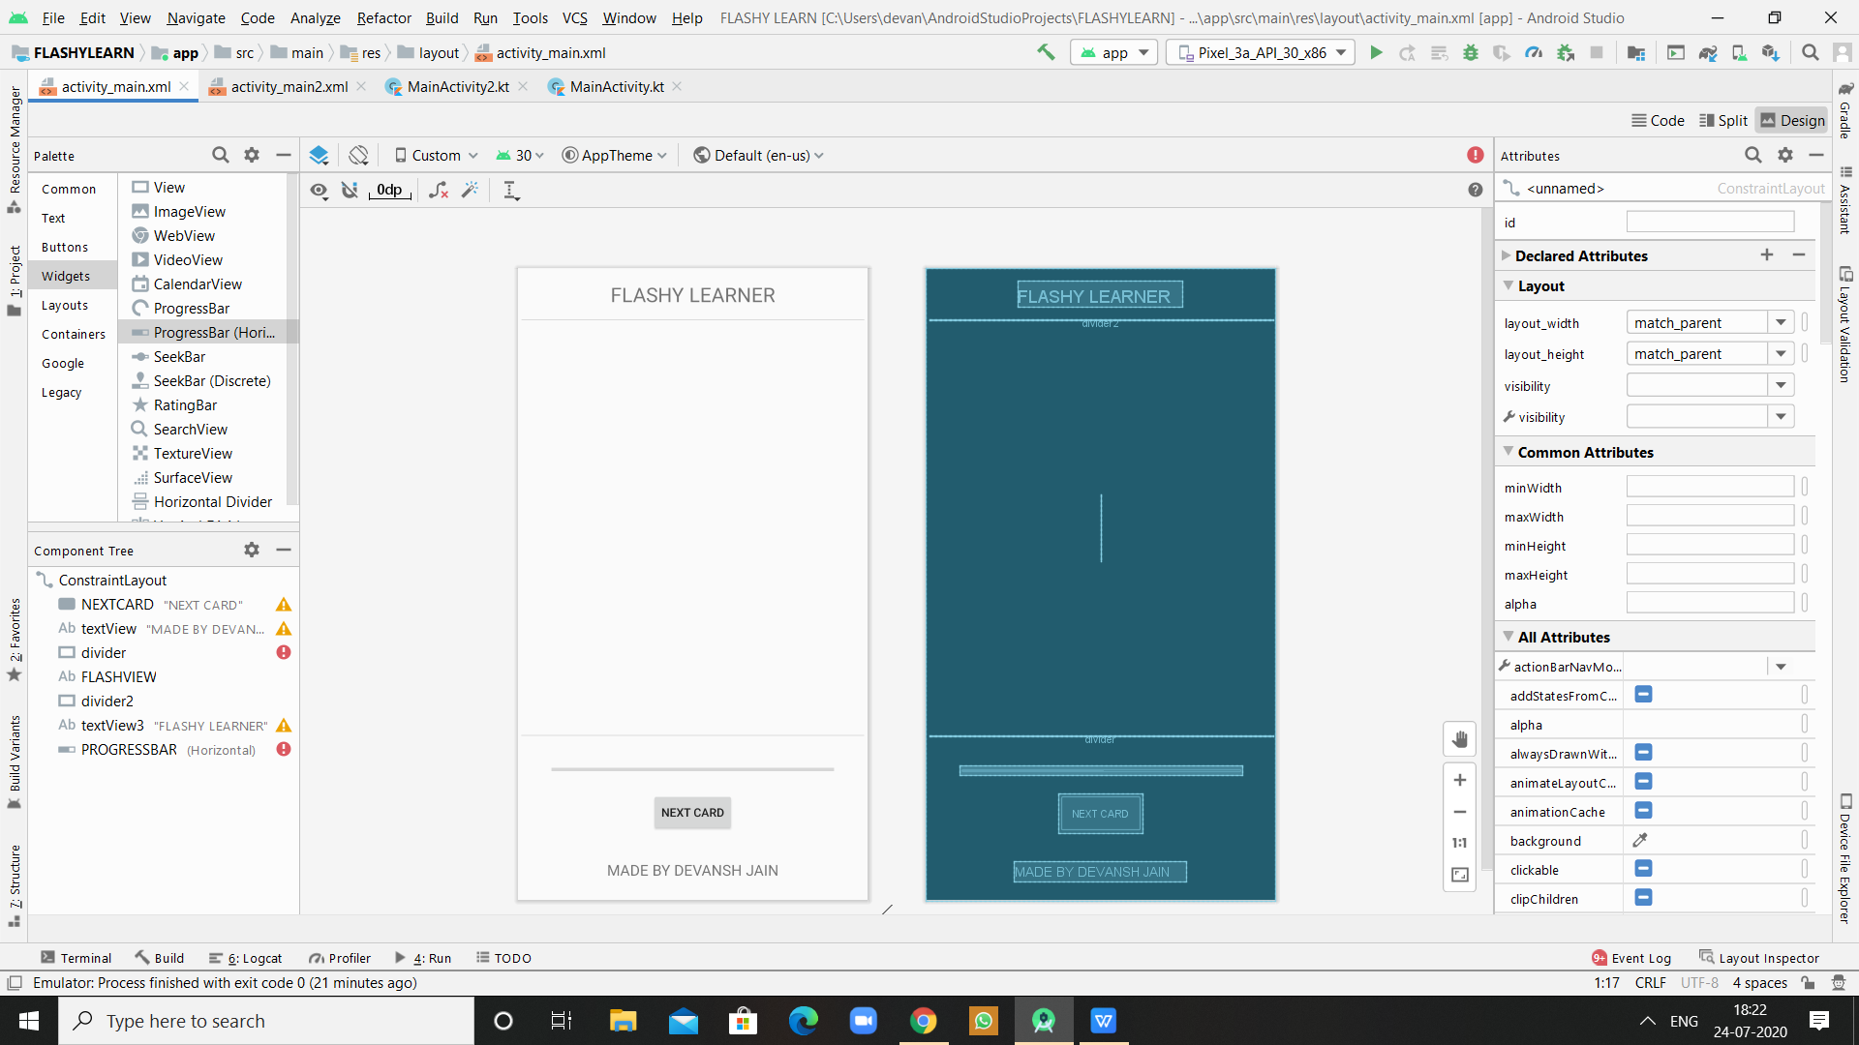

1. In The Screen 2 The user can learn and practice their Flash Cards
2. There is a Progress Bar which shows How much flash cards the user has completed and how much are left
3. When the user presses the next card button he will see his immediate answer and after that he will see his next card
4. This process will continue until the user finisher all the flash cards he has entered
5. I wanted to add an EXIT button but I wasn’t able to add it.

CODE

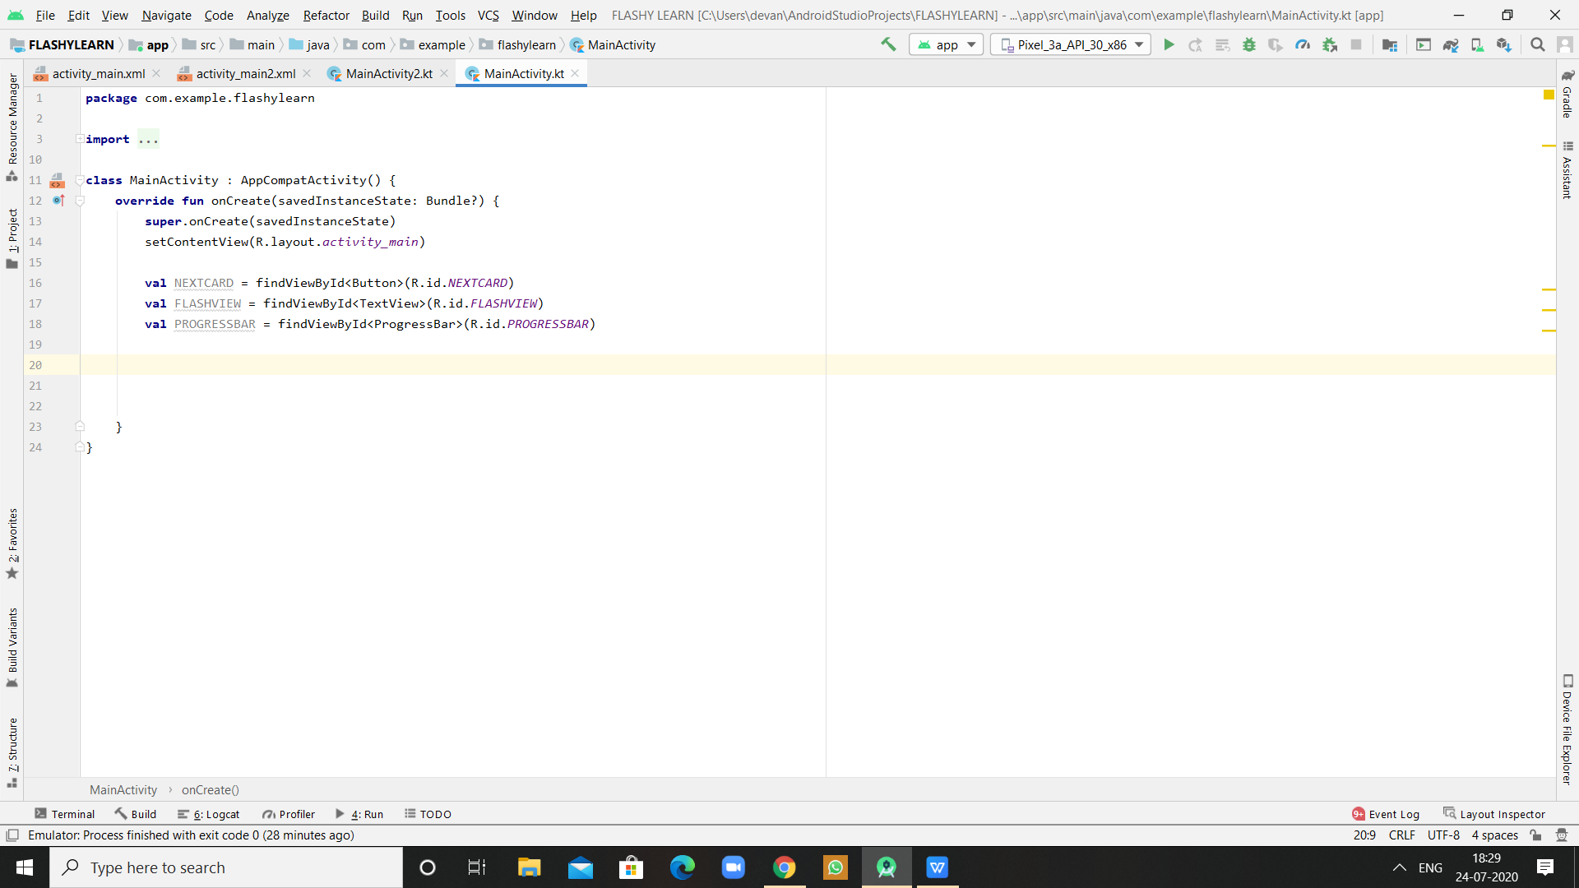

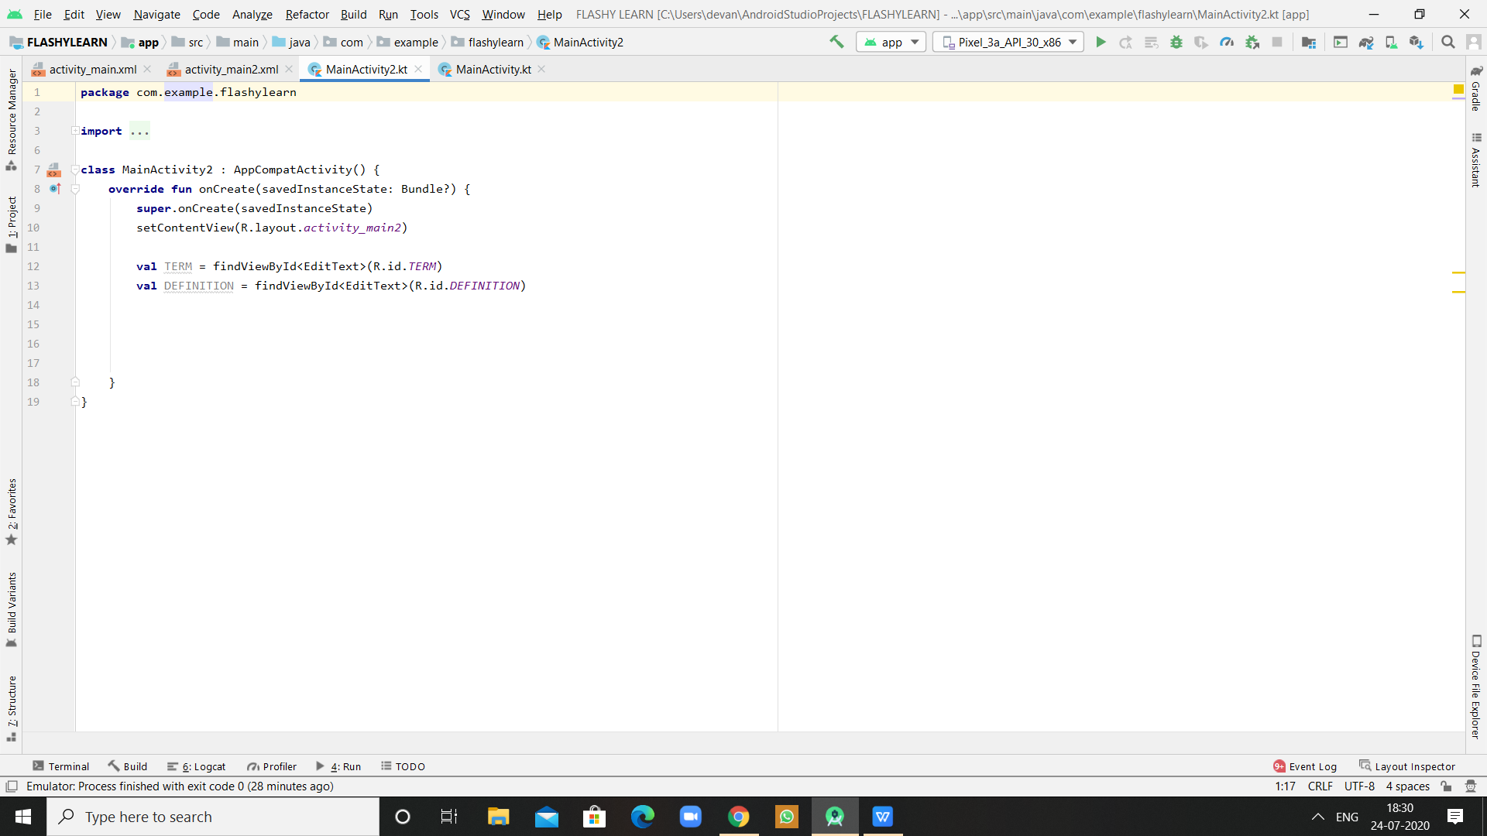

So I wasn’t able to complete the code but I just connected all the Buttons and Texts And Progress bar To the app design

The code of entering the text ,saving it and showing it in the screen 2 is left and the addition of EXIT Button and And ANSWER Button is left .

There wasn’t enough time to complete the project in because of daily online classes from 8 AM- 7PM and then too much homework and self study. I hope you can understand This.

I have a good Interest in App Dev and I want to pursue It in future and if you think That I have What It takes To Be a part of your Club Plz Consider Me as Im in no clubs or chapter as of now and will dedicate full time to your club.

Thank You